EXECUTIVE OFFICE OF ENERGY & ENVIRONMENTAL AFFAIRS
Richard Sullivan, Jr., Secretary
Contract for Services Opportunity Announcement

RFR ENV 13 CZM 09

Dated: April 18, 2013

Engineered Design Plans for Drift Road at Sam Tripp Brook Stormwater Remediation Project - Westport, MA

1. Contract for Services Opportunity Summary:

A. Proposals Sought For: The creation of stamped engineered site plans and supporting design calculations to address stormwater runoff from the Drift Road drainage system at Sam Tripp Brook (STB) in the Town of Westport, MA. (See map of the study area in Attachment A).

B. Overview and Goals: The Executive Office of Energy and Environmental Affairs (EEA), through the Buzzards Bay National Estuary Program (NEP) in the Massachusetts Office of Coastal Zone Management (CZM), announces the availability of $20,000 in federal funds to hire an engineering or environmental service firm. The goal of this project is to provide stormwater treatment to the Drift Road drainage system in the Town of Westport, MA, thereby reducing stormwater-related pollutants from discharging into the East Branch of the Westport River and ultimately changing the shellfish status from conditionally approved to open. The Buzzards Bay NEP staff will work with the selected vendor, the Town of Westport and the Westport River Watershed Alliance (WRWA) to decide upon the most practical stormwater management solutions given the constraints of the site.

C. Eligible Projects: Eligible projects include proposals for the identification and mapping of stormwater infrastructure and the development of a plan to treat stormwater originating from the STB/Drift Road drainage system in the Town of Westport, MA.

D. Eligible Applicants: Any qualified environmental engineering vendor with a Massachusetts registered Professional Engineer’s license that is responsive to this RFR, who meets the submission requirements and whose budget does not exceed $20,000 is eligible.

E. Application Deadline: (See further detail on deadlines and grant program calendar in section 4).

F. Funding Availability: A total of $20,000 in federal funds is available through this solicitation. The final funding amount is subject to approval. Exceptions may be made at the Secretary’s discretion (see further detail on Funding Availability in section 2C).

G. Match Requirement: No match is required for this award.

H. Total Anticipated Duration of Contract(s): The contract will last approximately 5.5 months, with the contract (expected to be) issued in mid-July 2013, with a closing date of December 31, 2013. However, where needed, and with the approval of EEA, contracts may be written or extended to June 30, 2014. (See further detail on anticipated duration of contract(s) in section 2F).

I. Regulations, Statutes, or Authorization Governing this Contract for Services Opportunity: Cooperative agreements between the Commonwealth of Massachusetts and the US EPA, in support of the Buzzards Bay National Estuary Program govern this contract for services.

J. Small Business Purchasing Program: This is a small procurement targeted to small businesses participating in the Commonwealth's Small Business Purchasing Program (SBPP). The Department intends to evaluate bid responses from and to award a contract to a SBPP-participating business(es) who submit a bid that meets or exceeds the solicitation criteria only. If determined that there is inadequate SBPP capacity, or no SBPP-participating vendors provide a responsive bid, the Department will evaluate and award bid responses received from non-SBPP businesses. To determine eligibility and to participate in the SBPP, please review the requirements and general program information at www.mass.gov/sbpp.

K. Contact Information: Sarah Williams, Regional Planner
Buzzards Bay National Estuary Program/CZM
2870 Cranberry Highway
East Wareham, MA 02538
Phone (508) 291-3625 ext 13
Fax (508) 291-3628
sarah.williams@state.ma.us
Website: buzzardsbay.org

2. Performance and Contract Specifications

A. Eligible Applicants: Eligible applicants include any qualified environmental engineering vendor with a Massachusetts registered Professional Engineer’s license that is responsive to this RFR, who meets the submission requirements and whose budget does not exceed $20,000.

B. Eligible Project(s)/Scope(s) of Work: The Executive Office of Energy and Environmental Affairs (EEA), through the Buzzards Bay National Estuary Program (NEP) in the Massachusetts Office of Coastal Zone Management (CZM), has allocated $20,000 of federal funds to hire an engineering or environmental service firm to assist the Town of Westport with the identification and mapping of stormwater infrastructure and the development of a plan to treat stormwater originating from the STB/Drift Road drainage system in the Town of Westport, MA. These funds are available in accordance with U.S. EPA National Estuary Program Cooperative Agreements through the Buzzards Bay Watershed Municipal Grant Program implemented by the Buzzards Bay NEP.

Sam Tripp Brook (STB) flows in a southwest/west to east direction under Drift Road via culvert and eventually discharges into the East Branch of the Westport River. The culvert under Drift Road has recently undergone renovation due to a collapse of the old culvert system. Stormwater from Drift Road flows from the north (relatively flat) and south (fairly steep) to all four corners of the new headwall culvert. All of the discharges, with the exception of the southeast, are roadcuts. The southeast drainage system consists of a catchbasin that discharges into a concrete waterway. This waterway then flows into another catchbasin and then into the outlet pipe.

The runoff from the Drift Road drainage system is primarily generated from Drift Road. Several driveways are evident along the west side of Drift Road and will need to be investigated for contributing runoff. Based upon discussions with the Town Administrator and the Highway Department, other than the drainage system along the northeast side of the road, the town does not provide any additional infrastructure (such as sewer and water). All abutting properties are on septic systems and individual wells.

The goal of this project is to provide stormwater treatment to the STB/Drift Road drainage system thereby reducing stormwater-related pollutants from discharging into the East Branch of the Westport River and contributing to water quality degradation. The Buzzards Bay NEP staff will work with the selected vendor, the Town of Westport and the WRWA to decide upon the most practical stormwater management solutions given the constraints of the site. WRWA has been in contact with abutting landowners regarding the potential of using privately-owned land for stormwater treatment.

Task 1- Data Inventory, Collection, and Analysis
The principal end product to be produced by the vendor is stamped engineer site plans and supporting design calculations to address stormwater runoff from the STB/Drift Road drainage system in Westport. The drainage system discharges in Sam Tripp Brook from a series of road cuts and one drainage pipe. A locus map and description of the site are shown in Attachment A of this RFR. These maps, together with supplemental GIS data sets, are also posted at http://www.buzzardsbay.org/bbnep-engineering-procurements.htm as well in Attachment A of this RFR. The site plans and calculations must be provided in sufficient detail for the town to meet all the necessary permit submission requirements and allow for implementation (construction drawings and specifications) of the project.

The contractor shall be responsible for preparing an existing-condition plan as specified in Task 2 to adequately document the stormwater runoff contributing to the Sam Tripp Brook and provide information with regards to potential stormwater treatment sites. The existing conditions plan must include the following tasks:
- If selected treatment option is within Drift Road or within its layout, plan and profile of the road section with the associated road layout. Locations of individual driveways and property bounds.
- Determination of contributing area to the individual discharge points (roadcuts and pipe drainage), including both pervious and impervious surfaces on private and public property.
- If needed, additional documentation (soil logs and water table) of soil conditions. The Westport Highway Department will provide the equipment and operator to dig all test pits.
Onsite investigations must be coordinated through the Westport Town Administrator’s Office and the Westport Highway Department with private property-owners’ concurrence.

All data collection, assessment information, site(s) evaluation, etc., will be subject to Buzzards Bay NEP review and approval.

Task 2 – Designs
The selected consultant will review all data, including that gathered from the fieldwork, and have working knowledge of the dynamics at the site to develop preliminary, draft final and final designs and plans for the stormwater treatment system and existing conditions as specified in Task 1. At each stage, the consultant will prepare a brief synopsis of the results of this review; identify potential areas of difficulty, if any; and any special considerations needed during a subsequent construction phase of the project. The selected vendor will prepare four (4) sets of preliminary review plans and meet with Buzzards Bay NEP, staff from the town of Westport and representatives from the WRWA to discuss the preliminary plans. Any and all data collection, assessment information, paper and electronic information will be public information and be provided to the Town of Westport, WRWA, and other property owners to verify the accuracy and veracity of the information. All data, information, plans, etc must be available as a paper copy and also in an electronic format acceptable to the Buzzards Bay NEP. The Buzzards Bay NEP and the Town of Westport will make available any data, GIS coverages, and information already collected with regards to this project. The Buzzards Bay NEP will prepare written comments within 10 working days for the consultant based on this meeting.

Based upon approval with requested changes of the preliminary designs as approved by the Buzzards Bay NEP, Town of Westport and WRWA, the contractor will prepare four (4) sets of draft final designs acceptable for permitting and construction purposes. Draft final designs will be reviewed and approved by the town, the Buzzards Bay NEP and WRWA. These draft final plans will be presented to the Westport Board of Selectmen at a public meeting. The Buzzards Bay NEP will prepare written comments within 10 working days of this meeting. Based on the public meeting and written comments, the vendor will prepare five (5) copies of final plans including estimated costs of materials, construction costs, and permitting.

The selected vendor is not required to prepare a construction bid specifications document as part of their work, however they may include this, and other tasks with proposed costs under a heading called “Optional Additional Tasks and Costs” in their response.

Task 3 – Meetings
The contractor will set up and attend the following meetings:
- An initial meeting with the Buzzards Bay NEP, staff from the town of Westport and the WRWA to discuss goals and objectives.
- A meeting with the Buzzards Bay NEP, staff from the town of Westport and the WRWA to discuss preliminary design.
- A public meeting with the Westport Board of Selectmen to discuss the draft final design plans.
- A meeting with the Buzzards Bay NEP, WRWA and pertinent town staff upon completion of the final design.

In addition, the contractor must provide monthly status reports (via email or letter) regarding the progress of the project.

C. Funding Availability, Budgeting Guidelines & Allowable Expenditures: A total of $20,000 of federal funds is available through this solicitation. The final funding amount is subject to approval by EEA. All contracts shall be subject to available funding, whether through the appropriation and authorization of sufficient funds or the receipt of sufficient revenues. If available funding ceases for any reason, a contract shall be deemed under suspension and contract performance must halt. A contractor will not be entitled to compensation for any performance provided during the period of contract suspension. EEA may lift the suspension if available funding is received. In the absence of foreseeable available funding, EEA may terminate the contract.

D. Match Requirement: No match is required for this award.

E. Project Terms: A final contract is subject to successful negotiation of a Final Scope of Services. If selected for a contract award, failure to submit any of the required forms prior to contract signing may be grounds for disqualification. Please note that EEA does not guarantee that any contracts may result from this RFR or that any particular funding level will be awarded. It is anticipated that the project would commence immediately upon EEA's decision. The awarded contract will be reviewed during its course and, upon request by the Contractor, may be extended or otherwise amended at the sole discretion of EEA. Any extensions granted will not necessarily change, or increase, the monetary value of the contract.

F. Anticipated duration of contracts: The contract is anticipated to be issued in mid-July 2013, and to last for approximately 5.5 months, closing on December 31, 2013. However, where deemed necessary by the Buzzards Bay NEP, and with the approval of EEA, contracts may be written or extended to June 30, 2014. Contracts must be completed in their entirety by their contract end date. Awarded contracts will be reviewed during their course, and upon request by the contractor, may be extended, at the sole discretion of EEA and subject to constraints of the funding source. Contractors must make all extension requests no later than 60 days prior to contract expiration.

G. Deliverables, Ownership, and Credit Due: All materials, software, maps, studies, reports, and other products or data, regardless of physical form or characteristics, produced as a result of this solicitation and funded, in whole or in part, under a contract with EEA shall be considered in the public domain and available to the Commonwealth and its municipalities, and the U.S. Environmental Protection Agency (EPA) at the reasonable cost of reproduction in any of the formats in which it is stored or maintained. The contractor shall not obtain, attempt to obtain, or file for a patent, copyright, trademark or any other interest in any such materials, software, maps, reports, and other products or data without the express, written consent of the EEA and subject to any other approvals required by state or federal law. Reports and other deliverables will credit the Buzzards Bay NEP, EEA, and EPA for any work completed under the grant award.

H. Reporting: Brief progress reports will be required monthly via email or written correspondence describing the progress status or impediments to progress.

I. Invoicing: Contract funds are awarded on a reimbursement basis for expenditures made during the period of the contract. Only those tasks/deliverables completed after contract execution, and identified in the scope of work, are eligible for reimbursement. Expenditures made outside of the period of the executed contract are ineligible for reimbursement. Reimbursement is generally made within 30 days subsequent to the receipt of a correctly executed invoice with appropriate backup and completed match certification. Reimbursement requests shall not be made more than monthly.

3. Instructions for Application Submission

A. Evaluation Criteria: A review committee composed of Buzzards Bay NEP staff and/or Town of Westport and Westport River Watershed Alliance staff will evaluate all proposals on a competitive basis. The review committee may include a non-governmental representative to serve in an advisory role to the committee.

Using the Selection Criteria presented below, the review committee will judge all qualified proposals on a competitive basis and assign a score to each, and based on these scores, assign a rank order to each proposal. The average rank score among all reviewers shall be the basis of vendor selection, with the highest mean-ranked proposal receiving funding. In the case of a tie rank score, funding will go to the proposal with the lowest cost. The review committee reserves the right to reject any or all proposals that do not meet the goals and terms of this RFR. The scoring sheet that will be used during the review process is located in Attachment B of the RFR.

Selection Criteria (20 possible points):
- Description of the Approach to the Proposed Work (12 pts)
- Past Experience (4 pts)
- References for Performance Evaluation (4 pts)

The proposal review process, and the subsequent approval of the selected vendor by EEA, generally takes several weeks. During this time, we cannot discuss the status of the selection procedure with any of the applicants. Once EEA completes and finalizes the selection, all applicants will be notified in writing as to whether they were selected for funding.

NOTE: EEA reserves the option to interview some or all of those submitting proposals for clarifying purposes prior to making a final award. Incomplete or incorrectly submitted applications will be disqualified. If there are insufficient qualifying eligible proposals to utilize all funds, the Buzzards Bay NEP will direct any remaining funds to a future Buzzards Bay NEP Municipal Grant round.

B. Application Submission Instructions: Interested vendors should modify and expand upon the scope, within the limitations of the budget and schedule, to address the needs presented in this Request for Responses and to include any elements not identified, but which are necessary to meet the objectives of this RFR. Failure to provide any of the materials listed below may result in the disqualification of the proposal.

At a minimum, the response shall include:
- A brief cover letter on the vendor’s stationary.
- A completed coversheet (located in Attachment C of this RFR).
- A detailed work plan that addresses the goals of the project, including tasks 1 through 3 in Section 2 (Performance and Contract Specifications) of this RFR, and other items the project team deems are necessary to make this a successful project. If selected for funding, the vendor’s contract will include their proposed scope of work (or a similar, agreed upon scope).
- A proposed schedule and timeline for completing each of the project tasks in the work plan. Have the timeline start after the proposed contract start date (July 2013). The deadline for task completion is December 31, 2013.
- Company profile and descriptions of similar (completed) projects to the one proposed in the RFR.
- Three to five client references of work conducted on similar projects (contact names, addresses and telephone numbers).
- All of the required forms posted on Comm-Pass (see section C below)

The deadline for proposal submission is Thursday, May 30, 2013 by 4:00 PM. Please submit five complete copies of the application form and any attachments to:

Sarah Williams, Regional Planner
Buzzards Bay National Estuary Program/CZM
2870 Cranberry Highway
East Wareham, MA 02538

Fax and/or email submissions are not acceptable. Additionally, postmarks are not acceptable as verification of date of submission. When submitting applications, please double-side them where practicable, and minimize/eliminate the use of non-recyclable materials such as plastic or vinyl binders, folders, and covers.

C. Additional Required Documentation:
The Respondent will be required to submit the following forms with their proposal:
- Commonwealth Terms and Conditions filled out and signed by the Respondent
- Commonwealth W-9 tax information form filled out and signed by the Respondent.
- Completed Contractor Authorized Signature Verification Form.
- Prompt Payment discount form
- Electronic Funds Transfer Authorization form

*Note: Pursuant to the Federal Funding Accountability and Transparency Act (FFATA) and Massachusetts state finance law, respondents, if selected, must submit the most current W-9 form listing the respondent’s tax identification and DUNS numbers.

The forms are available on Comm-PASS as part of this solicitation.

4. Deadlines and Procurement Calendar

A. Release of RFR: April 18, 2013

B. Information Session: A Bidders’ Conference will be held at 11:00 AM on Tuesday, May 7, 2013 at the site of the proposed remediation project, which is approximately 0.65 of a mile from the intersection of Hix Bridge Road (heading south). Parking at the site is difficult and limited, so it is highly recommended that those attending car-pool when possible.

C. inquiries about the rfr: The Regional Planner will accept questions about this RFR in writing by mail, fax, or email through 4 PM, Friday, May 10, 2013. Additionally, questions are acceptable at the bidder’s conference on May 7, 2013. The Buzzards Bay NEP will post responses to questions (including those received at the site visit), if any, on their website www.buzzardsbay.org/bbnep-engineering-procurements.htm by Friday, May 17, 2013, as well as on www.Comm-Pass.com. These answers are for clarification purposes only and do not constitute an amendment to the RFR unless expressly stated as such.

D. Application Due Date: Thursday, May 30, 2013 by 4:00 PM

E. Estimated Award Date: If selected for funding, the vendor will receive written notification from the Buzzards Bay NEP, subject to final contract execution. Soon after selection, the Commonwealth of Massachusetts, Executive Office of Energy and Environmental Affairs will execute a standard Terms and Conditions Contract between itself and the vendor. The vendor’s appropriate legal authority must sign the contract. Contract funds are awarded on a reimbursement basis for expenditures made during the period of the contract. Expenditures made outside of the period of the executed contract are ineligible for reimbursement. The state comptroller’s office will wire electronic reimbursement payments to the vendor’s account, usually within 30 days of receipt of a properly executed reimbursement request. The vendor must complete all work by December 31, 2013.

F. Estimated Contract Start Date: The estimated contract start date resulting from this RFR is mid-July 2013. Notwithstanding any verbal representations by the parties, or an earlier start date listed in the Standard Contract Form, and only after an award is issued and a final scope of services has been negotiated, the effective start date of a contract shall be the latest of the following dates: the date the Standard Contract Form has been executed by an authorized signatory of the contractor and the procuring department; the date of secretariat or other approval(s) required by law or regulation; or a later date specified in the Standard Contract Form.

5. Miscellaneous
A. Type of Procurement: Contract for Services

B. Use of This Procurement by Single or Multiple Departments: This RFR is a single department procurement. All contracts awarded under this RFR will be utilized solely by EEA.

C. Request for Single Or Multiple Contractors: This solicitation will result in a single contract award.

D. RFR Distribution Method: This RFR has been distributed electronically using the Comm-PASS system. It will also be posted on the Buzzards Bay NEP website at www.buzzardsbay.org/funding.htm. It is the responsibility of every Applicant to check Comm-PASS for any addenda or modifications to an RFR to which they intend to respond. The Commonwealth of Massachusetts and its subdivisions accept no liability and will provide no accommodations to Applicants who fail to check for amended RFRs and submit inadequate or incorrect responses. Potential Respondents are advised to check the “last change” field on the summary page of RFRs for which they intend to submit a response to ensure they have the most recent RFR files.

E. List of Attachments:
- Maps of Site
- Scoring Sheet
- Cover Sheet (must be completed and submitted with proposal)
- EEA Supplemental Terms and Conditions

Attachment A
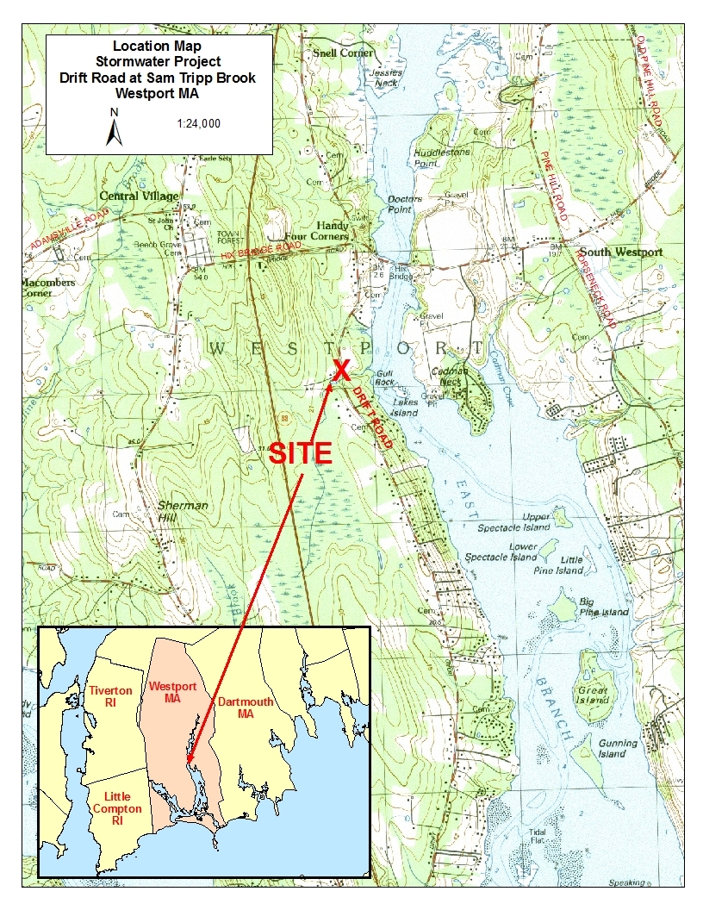
Maps of site - LOCUS MAP
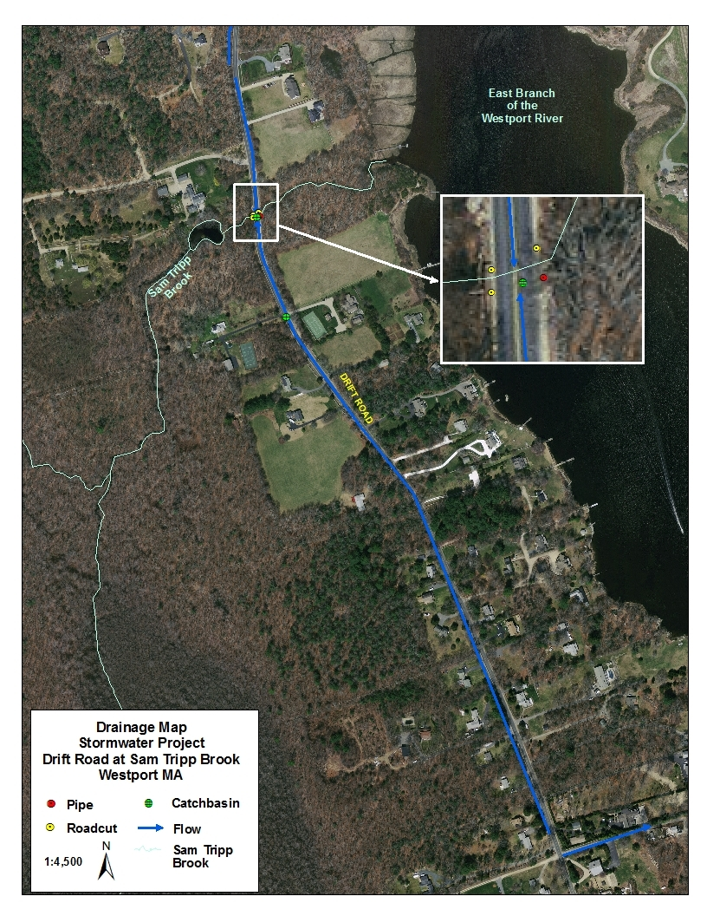
STUDY AREA MAP
Attachment B:
Scoring Sheet for Engineered Design Plans for Drift Road at Sam Tripp Brook
Stormwater Remediation Project - Westport, MA

ENV 13 CZM 09

Vendor: ______________________________________________

Amount Requested:_______ ___Reviewer:__________________________Total Pts______ (20 pts max)
Rank among all proposals received: ____ (1= best) of ____ (total)

1) Description of the Approach to the Proposed Work ______ pts (12 points max)
Detail provided in the response including the project approach, timeline, and all other minimum submittal requirements, as well as a demonstrated understanding of project goals and scope.
Reviewer Comments:

2) Past Experience ______ pts (4 points max)
Rate the vendor’s experience, within Massachusetts, with similar stormwater site assessment or plan development projects, or with the state stormwater standards. Rate the vendor’s experience in terms of years and numbers of projects.
Reviewer Comments:

3) References for Performance Evaluation ______ pts (4 points max)
Rate the vendor’s references from clients from related projects to help characterize the firm's experience in completing projects on a timely basis and within the appropriated budget, and their ability to work collaboratively with government agencies.
Reviewer Comments:

Funding is dependent on final rank score, with the highest scored proposal receiving funding. In the case of a tie score, funding will go to the proposal with the lowest cost. The review committee reserves the right to reject any or all proposals that do not meet the goals and terms of this RFR.

Overall Comments:

Reviewer Signature:____________________________ Date:___________
Attachment C:
Cover Sheet

EXECUTIVE OFFICE OF ENERGY AND ENVIRONMENTAL AFFAIRS
OFFICE OF COASTAL ZONE MANAGEMENT
BUZZARDS BAY NATIONAL ESTUARY PROGRAM

REQUEST FOR RESPONSES

Engineered Design Plans for Drift Road at Sam Tripp Brook
Stormwater Remediation Project - Westport, MA

ENV 13 CZM 09
RFR Release Date: April 16, 2013

Vendor: ______________________________________________________________________

Proposal contact: ____________________________________Title:______________________

Phone: __________________________ Fax:_____________________________

Email: ___________________________________________________________

Project manager (if different):__________________________________Title:_______________

Phone: __________________________ Fax:_____________________________

Email: ___________________________________________________________

Proposal Amount: $____________

Attachment D
EEA Supplemental Terms & Conditions

See attached sheet on Comm-Pass solicitation under Forms & Terms tab.

