EXECUTIVE OFFICE OF ENERGY & ENVIRONMENTAL AFFAIRS

Richard Sullivan, Jr., Secretary

Contract for Services Opportunity Announcement

RFR ENV 13 CZM 07

Dated: December 14, 2012

Engineered Design Plans for Main Street – Wareham River Estuary Outfall Mitigation Project - Wareham, MA

1. Contract for Services Opportunity Summary:

A. Proposals Sought For: The creation of stamped engineered site plans, supporting design calculations, and permit applications to address stormwater runoff from the Main Street drainage system in the Town of Wareham, MA. (See map of the study area in Attachment A).

B. Overview and Goals: The Executive Office of Energy and Environmental Affairs (EEA), through the Buzzards Bay National Estuary Program (NEP) in the Massachusetts Office of Coastal Zone Management (CZM), and in partnership with the Town of Wareham’s Community and Economic Development Authority (CEDA), announces the availability of $20,000 in federal funds to hire an engineering or environmental service firm. The purpose of this project is to develop stormwater treatment designs for the Main Street drainage system in the Town of Wareham, MA to reduce stormwater-related pollutants discharging to the upper Wareham River estuary. The ultimate goal of the completed project is to help reduce bacteria discharges to the upper estuary, which will help contribute to possible reductions in the area or duration of current shellfish resource area closures. The Buzzards Bay NEP staff will work with the selected vendor, Wareham Public Works, and CEDA, to decide upon the most practical stormwater management solutions, given the site conditions and drainage area. A special constraint of this project is portions of the design area must be completed by early-April so that this information can be included into a construction bid planned by CEDA for their Wareham Phase II streetscape work.

C. Eligible Projects: Eligible projects include proposals for the identification and mapping of stormwater infrastructure and the development of a plan to treat stormwater originating from the Main Street drainage system in the Town of Wareham, MA in accordance with the specified deadlines.

D. Eligible Applicants: Any qualified environmental engineering vendor with a Massachusetts registered Professional Engineer’s license that is responsive to this RFR, who meets the submission requirements and whose budget does not exceed $20,000 is eligible.

E. Application Deadline: Friday, January 11, 2013 by 4:00 PM (See further detail on deadlines and grant program calendar in section 4).

F. Funding Availability: A total of $20,000 in federal funds is available through this solicitation. The final funding amount is subject to approval. Exceptions may be made at the Secretary’s discretion (see further detail on Funding Availability in section 2C).

G. Match Requirement: No match is required for this award.

H. Total Anticipated Duration of Contract(s): The contract will last approximately 4 1/2 months, with the contract (expected to be) issued with a February 15, 2013 notice to proceed, with a closing date of June 30, 2013.

I. Regulations, Statutes, or Authorization Governing this Contract for Services Opportunity: Cooperative agreements between the Commonwealth of Massachusetts and the US EPA, in support of the Buzzards Bay National Estuary Program, and all relevant Massachusetts state laws and regulations govern this contract for services.

J. Small Business Purchasing Program: This is a small procurement targeted to small businesses participating in the Commonwealth's Small Business Purchasing Program (SBPP). The Department intends to evaluate bid responses from and to award a contract to a SBPP-participating business(es) who submit a bid that meets or exceeds the solicitation criteria only. If determined that there is inadequate SBPP capacity, or no SBPP-participating vendors provide a responsive bid, the Department will evaluate and award bid responses received from non-SBPP businesses. To determine eligibility and to participate in the SBPP, please review the requirements and general program information at www.mass.gov/sbpp.

K. Contact Information: Sarah Williams, Regional Planner
Buzzards Bay National Estuary Program/CZM
2870 Cranberry Highway
East Wareham, MA 02538
Phone (508) 291-3625 ext 13
Fax (508) 291-3628
sarah.williams@state.ma.us
Website: buzzardsbay.org

2. Performance and Contract Specifications

A. Eligible Applicants: Eligible applicants include any qualified environmental engineering vendor with a Massachusetts registered Professional Engineer’s license that is responsive to this RFR, who meets the submission requirements and whose budget does not exceed $20,000.

B. Eligible Project(s)/Scope(s) of Work: The Executive Office of Energy and Environmental Affairs (EEA), through the Buzzards Bay National Estuary Program (NEP) in the Massachusetts Office of Coastal Zone Management (CZM), has allocated $20,000 of federal funds to hire an engineering or environmental service firm to assist the Town of Wareham with the identification and mapping of stormwater infrastructure and the development of a plan to treat stormwater originating from the Main Street drainage system in the Town of Wareham, MA, discharging to the Wareham River Estuary. These funds are available in accordance with U.S. EPA National Estuary Program Cooperative Agreements through the Buzzards Bay Watershed Municipal Grant Program implemented by the Buzzards Bay NEP.

The Town of Wareham’s Community and Economic Development Authority (CEDA) applied for and received a stormwater remediation design grant for $20,000 administered through the Buzzards Bay NEP. The intent of this grant is to fund the final design of engineered plans for the remediation of two outfalls that discharge stormwater to the upper Wareham River estuary. The first discharge is located near the municipal pump station on Merchant’s Way (see Site Map); the second is approximately 350 northwest of the first discharge.

Concurrently, the CEDA has also initiated with a revitalization project on Main Street that is within the drainage area for these two outfalls. To date, the Wareham CEDA has completed the final streetscape improvements from Center Street to roughly #266 Main Street, approximately 1,100 linear feet along Main Street completed under Phase I. Phase II (formerly phase III) continues from Center Street to the intersection of Main Street and Sandwich Road. There is a completed design for the streetscape renovation for Phase II which includes topographic survey suitable for that discipline of construction.

The approach for this design will include delineation of the drainage areas for the two outfalls proposed for remediation and a series of designs at the 50, 75, and 100% design levels and project permitting. The desire of the Wareham CEDA is to bid a package of design plans including the 100% Phase II streetscape design (by others) and stormwater BMPs (developed by this RFR) for the two outfalls, if the BMPs recommended are within the Phase II streetscape work. The latest expected date to advertise the bidding package is mid April.

Task 1- Data Inventory, Collection, and Analysis
Identify the contributing area for each of the two outfalls discharging stormwater to the Wareham River estuary. Delineation shall include all impervious area contributing to the stormwater discharges, both publically and privately-owned. Results shall quantify volumes for 0.5”, 1.00” and 1.25” of runoff. A locus map and description of the site are shown in Attachment A of this RFR. These maps, together with supplemental GIS data sets, are also posted at http://www.buzzardsbay.org/bbnep-engineering-procurements.htm . Some elements of this task may already be including in existing town and CEDA plans.

Deliverables for this task are existing-condition plans showing catch basins, drainage structures, piping and contributing area of each outfall at a scale suitable for presentation. The principal end product to be produced by the vendor is stamped engineer site plans and supporting design calculations to address stormwater runoff contributing to the two discharges. The site plans and calculations must be provided in sufficient detail for the town to meet all the necessary permit submission requirements and allow for implementation (construction drawings and specifications) of the project. The existing conditions plan must include the following tasks:
- Plan of all the roads (including the town-owned road layout) and piped drainage system contributing to the two discharges. Profiles would be required for the proposed designs at the 75% and 100% levels.
- Location of all utilities and associated services to individual homes and/or businesses.
- Locations of individual driveways, curb cuts, and access ways. Detailed property line delineation will be required for final design of any system that would impact private property.
- Determination of contributing area to the discharge point, including both pervious and impervious surfaces.
- If needed, additional documentation (soil logs and water table) of soil conditions. The Wareham Public Works Department will provide the equipment and operator to dig all test pits.
Onsite investigations must be coordinated through the Wareham CEDA

Completion Date. March 1, 2013, or 2 weeks from Notice to Proceed.

All data collection, assessment information, site(s) evaluation, etc., will be subject to Buzzards Bay NEP review and approval. Any and all data collection, assessment information, paper and electronic information will be public information and provided to the Town of Wareham, CEDA, and other property owners to verify the accuracy and veracity of the information. The Buzzards Bay NEP and the town of Wareham will make available any data, GIS coverages, and information already collected with regards to this project.

Task 2 – Design Strategy Meeting.
Based on the findings of Tasks 1, the contractor will meet with project stakeholders to deliver and discuss drainage area delineations and flow calculations, and discuss goals, strategies, conceptual BMP design approaches, lines of communication, and principals for achieving project goals. This meeting will be used to develop a consensus about viable BMP design locations and integration with the Phase II streetscape project.
Deliverables: Meeting minutes.
Tentative Completion Date: March 1, 2013.

Task 3 – 50% Design and Meeting
The contractor will meet with project stakeholders and deliver three (3) sets of 50% designs, and a PDF file of these designs, showing BMP location, type and size. The consultant will prepare a brief synopsis identifying potential areas of difficulty, if any; and any special considerations needed during a subsequent construction phase of the project. The Buzzards Bay NEP will prepare written comments on behalf of all partners, within 10 working days for the consultant based on this meeting.
Deliverables: 50% design plans (paper and electronic).
Tentative Completion Date: March 15, 2013.

Task 4 – 75% Design and Meeting
The contractor will meet with project stakeholders and deliver three (3) sets of 75% design plans, and a pdf file of these plans, showing response to the 50% design. Design plans to include site plans, proposed conditions, notation, construction details, and cost estimate. The Buzzards Bay NEP will prepare written comments on behalf of all partners, within 10 working days for the consultant based on this meeting.
Deliverables: 75% design plans (paper and electronic) and cost estimate.
Tentative Completion Date: April 16, 2013.

Task 5 –Permitting
Prepare and develop required permits for construction as needed, possible permits include MADEP RDA or NOI, NHESP notification, Mass Historic Notification and others identified as necessary by the Buzzards Bay NEP.
Deliverables: All required permits submitted.
Completion Date: May 30, 2013.

Task 6 – Final Designs and Permitting
Based upon approval with requested changes of the 75% designs as approved by the Buzzards Bay NEP, Town of Wareham, and CEDA, the contractor will prepare three (3) sets of final designs plans suitable for construction, and a pdf file of these plans, and stamped by a licensed Massachusetts Professional Engineer. Address all comments provided by project stakeholders and permitting agency. In addition, the vendor shall supply CAD or GIS Shapefiles of the stormwater drainage network georeferenced to Mass State Plane (NAD83 ft) including elevations of structures and inverts (in NAVD88).
Deliverables: 100% design plans in paper and electronic form, stormwater network provided as CAD or shapefiles, and construction cost estimates.
Completion Date. June 14, 2013.

The selected vendor is not required to prepare a construction bid specifications document as part of their work, however they may include this, or any other tasks with proposed costs, if any, under a heading called “Optional Additional Tasks and Costs” in their response.

C. Funding Availability, Budgeting Guidelines & Allowable Expenditures: A total of $20,000 of federal funds is available through this solicitation. The final funding amount is subject to approval by EEA. All contracts shall be subject to available funding, whether through the appropriation and authorization of sufficient funds or the receipt of sufficient revenues. If available funding ceases for any reason, a contract shall be deemed under suspension and contract performance must halt. A contractor will not be entitled to compensation for any performance provided during the period of contract suspension. EEA may lift the suspension if available funding is received. In the absence of foreseeable available funding, EEA may terminate the contract.

D. Match Requirement: No match is required for this award.

E. Project Terms: A final contract is subject to successful negotiation of a Final Scope of Services. If selected for a contract award, failure to submit any of the required forms prior to contract signing may be grounds for disqualification. Please note that EEA does not guarantee that any contracts may result from this RFR or that any particular funding level will be awarded. It is anticipated that the project would commence immediately upon EEA's decision. The awarded contract will be reviewed during its course and, upon request by the Contractor, may be extended or otherwise amended at the sole discretion of EEA. Any extensions granted will not necessarily change, or increase, the monetary value of the contract.

F. Anticipated duration of contracts: The contract is anticipated to be issued in mid February 2013, and to last for approximately 4 1/2 months, closing on June 30, 2013. Contracts must be completed in their entirety by their contract end date. Awarded contracts will be reviewed during their course, and upon request by the contractor, may be extended, at the sole discretion of EEA and subject to constraints of the funding source. Contractors must make all extension requests no later than 60 days prior to contract expiration.

G. Deliverables, Ownership, and Credit Due: All materials, software, maps, studies, reports, and other products or data, regardless of physical form or characteristics, produced as a result of this solicitation and funded, in whole or in part, under a contract with EEA shall be considered in the public domain and available to the Commonwealth and its municipalities, and the U.S. Environmental Protection Agency (EPA) at the reasonable cost of reproduction in any of the formats in which it is stored or maintained. The contractor shall not obtain, attempt to obtain, or file for a patent, copyright, trademark or any other interest in any such materials, software, maps, reports, and other products or data without the express, written consent of the EEA and subject to any other approvals required by state or federal law. Reports and other deliverables will credit the Buzzards Bay NEP, EEA, and EPA for any work completed under the grant award.

H. Reporting: Brief progress reports will be required monthly via email or written correspondence describing the progress status or impediments to progress.

I. Invoicing: Contract funds are awarded on a reimbursement basis for expenditures made during the period of the contract. Only those tasks/deliverables completed after contract execution, and identified in the scope of work, are eligible for reimbursement. Expenditures made outside of the period of the executed contract are ineligible for reimbursement. Reimbursement is generally made within 45 days subsequent to the receipt of a correctly executed invoice with appropriate backup and completed match certification. Reimbursement requests shall not be made more than monthly.

3. Instructions for Application Submission

A. Evaluation Criteria: A review committee composed of Buzzards Bay NEP staff and Town of Wareham staff.

Using the Selection Criteria presented below, the review committee will judge all qualified proposals on a competitive basis and assign a score to each, and based on these scores, assign a rank order to each proposal. The average rank score among all reviewers shall be the basis of vendor selection, with the highest mean-ranked proposal receiving funding. In the case of a tie rank score, funding will go to the proposal with the lowest cost. The review committee reserves the right to reject any or all proposals that do not meet the goals and terms of this RFR. The scoring sheet that will be used during the review process is located in Attachment B of the RFR.

Selection Criteria (20 possible points):
- Description of the Approach to the Proposed Work Scoring will include any value added services (12 pts)
- Past Experience (4 pts)
- References for Performance Evaluation (4 pts)

The proposal review process, and the subsequent approval of the selected vendor by EEA, generally takes several weeks. During this time, we cannot discuss the status of the selection procedure with any of the applicants. Once EEA completes and finalizes the selection, all applicants will be notified in writing as to whether they were selected for funding.

NOTE: EEA reserves the option to interview some or all of those submitting proposals for clarifying purposes prior to making a final award. Incomplete or incorrectly submitted applications will be disqualified. If there are insufficient qualifying eligible proposals to utilize all funds, the Buzzards Bay NEP will direct any remaining funds to a future Buzzards Bay NEP Municipal Grant round.
B. Application Submission Instructions: Interested vendors should modify and expand upon the scope, within the limitations of the budget and schedule, to address the needs presented in this Request for Responses and to include any elements not identified, but which are necessary to meet the objectives of this RFR. Failure to provide any of the materials listed below may result in the disqualification of the proposal.

At a minimum, the response shall include:
- A brief cover letter on the vendor’s stationary.
- A completed coversheet (located in Attachment C of this RFR).
- A detailed work plan that addresses the goals of the project, including tasks 1 through 3 in Section 2 (Performance and Contract Specifications) of this RFR, and other items the project team deems are necessary to make this a successful project. If selected for funding, the vendor’s contract will include their proposed scope of work (or a similar, agreed upon scope).
- A proposed schedule and timeline for completing each of the project tasks in the work plan. Have the timeline start after the proposed contract start date (mid February 2013). The deadline for task completion of the contract is June 30, 2013.
- Company profile and descriptions of similar (completed) projects to the one proposed in the RFR.
- Three to five client references of work conducted on similar projects (contact names, addresses and telephone numbers).
- All of the required forms posted on Comm-Pass (see section C below)

The deadline for proposal submission is Friday, January 11, 2013 by 4:00 PM. Please submit five complete copies of the application form and any attachments to:
Sarah Williams, Regional Planner
Buzzards Bay National Estuary Program/CZM
2870 Cranberry Highway
East Wareham, MA 02538
ATTN: RFR ENV 13 CZM 07

Fax and/or email submissions are not acceptable. Additionally, postmarks are not acceptable as verification of date of submission. When submitting applications, please double-side them where practicable, and minimize/eliminate the use of non-recyclable materials such as plastic or vinyl binders, folders, and covers.

C. Additional Required Documentation:
The Respondent is required to submit the following forms with their bid submission:
- Commonwealth Terms and Conditions filled out and signed by the Respondent
- Commonwealth W-9 tax information form filled out and signed by the Respondent.
- Completed Contractor Authorized Signature Verification Form.
- Prompt Payment discount form
- Electronic Funds Transfer Authorization form

*Note: Pursuant to the Federal Funding Accountability and Transparency Act (FFATA) and Massachusetts state finance law, respondents, if selected, must submit the most current W-9 form listing the respondent’s tax identification and DUNS numbers.
These forms are available on Comm-PASS as part of this solicitation.
4. Deadlines and Procurement Calendar

A. Release of RFR: December 14, 2012

B. Information Session: A Bidders’ Conference will be held at 11:00 AM on Thursday, December 27, 2012 in the Merchant Way parking lot in Wareham, MA (near the lift station at the east end of the lot along the Wareham River estuary).

C. inquiries about the rfr: The Regional Planner will accept questions about this RFR in writing by mail, fax, or email through 4 PM, Wednesday, December 26, 2012. Additionally, questions are acceptable at the bidder’s conference on Thursday, December 27, 2012. The Buzzards Bay NEP will post responses to questions (including those received at the site visit), if any, on their website www.buzzardsbay.org/bbnep-engineering-procurements.htm by Thursday, January 3, 2013, as well as on www.Comm-Pass.com. These answers are for clarification purposes only and do not constitute an amendment to the RFR unless expressly stated as such.

D. Application Due Date: Friday, January 11, 2013 by 4:00 PM.

E. Estimated Award Date: If selected for funding, the vendor will receive written notification from the Buzzards Bay NEP, subject to final contract execution. Soon after selection, the Commonwealth of Massachusetts, Executive Office of Energy and Environmental Affairs will execute a standard Terms and Conditions Contract between itself and the vendor. The vendor’s appropriate legal authority must sign the contract. Contract funds are awarded on a reimbursement basis for expenditures made during the period of the contract. Expenditures made outside of the period of the executed contract are ineligible for reimbursement. The state comptroller’s office will wire electronic reimbursement payments to the vendor’s account, usually within 45 days of receipt of a properly executed reimbursement request. The vendor must complete all work by June 30, 2013.

F. Estimated Contract Start Date: The estimated contract start date resulting from this RFR is mid-February 2013. Notwithstanding any verbal representations by the parties, or an earlier start date listed in the Standard Contract Form, and only after an award is issued and a final scope of services has been negotiated, the effective start date of a contract shall be the latest of the following dates: the date the Standard Contract Form has been executed by an authorized signatory of the contractor and the procuring department; the date of secretariat or other approval(s) required by law or regulation; or a later date specified in the Standard Contract Form.

5. Miscellaneous
A. Type of Procurement: Contract for Services

B. Use of This Procurement by Single or Multiple Departments: This RFR is a single department procurement. All contracts awarded under this RFR will be utilized solely by EEA.

C. Request for Single Or Multiple Contractors: This solicitation will result in a single contract award.
D. RFR Distribution Method: This RFR has been distributed electronically using the Comm-PASS system. It will also be posted on the Buzzards Bay NEP website at www.buzzardsbay.org/funding.htm. It is the responsibility of every Applicant to check Comm-PASS for any addenda or modifications to an RFR to which they intend to respond.

E. List of Attachments:
- Maps of Site
- Scoring Sheet
- Cover Sheet (must be completed and submitted with proposal)
- EEA Supplemental Terms and Conditions

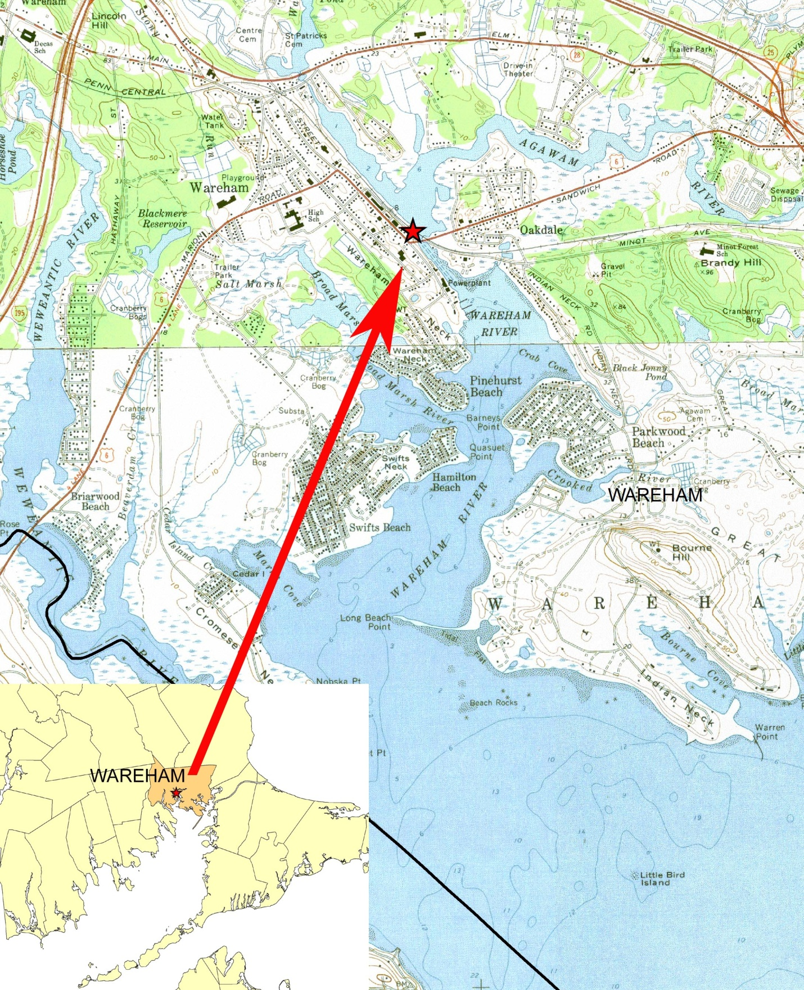
Attachment A
Maps of site
LOCUS MAP
STUDY AREA MAP
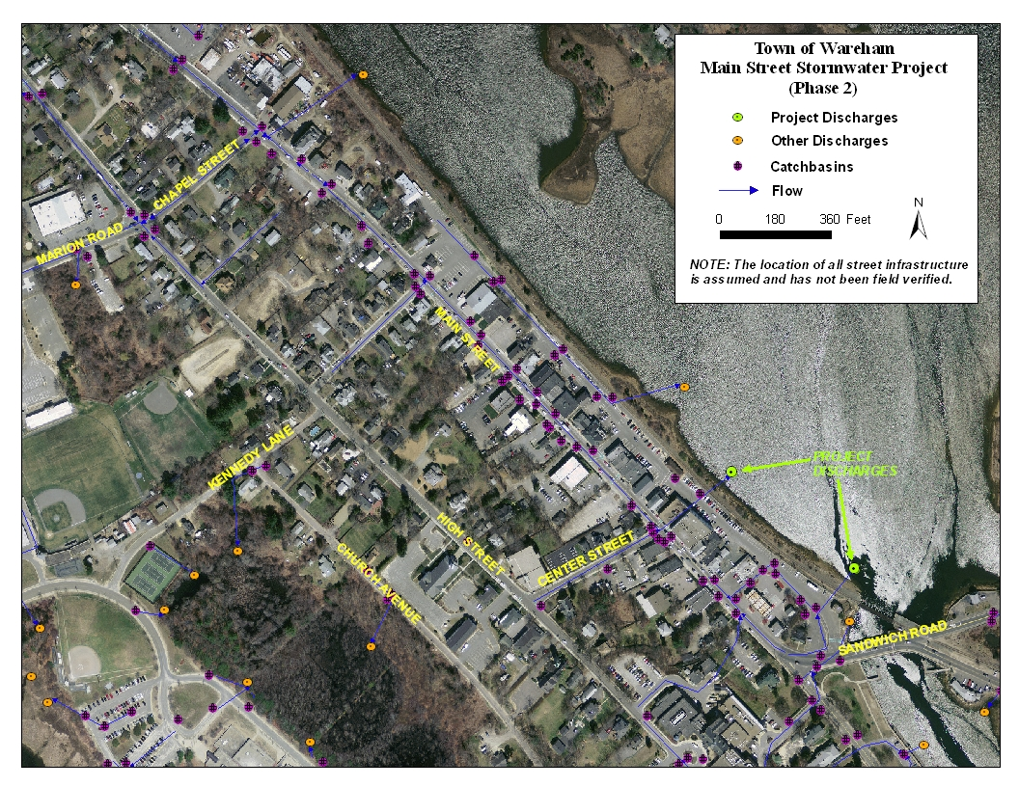
Attachment B:

Scoring Sheet for Engineered Design Plans for Main Street Stormwater Remediation Project Wareham, MA

ENV 13 CZM 07

Vendor: ______________________________________________

Amount Requested:_______ ___Reviewer: __________________________Total Pts______ (20 pts max)
Rank among all proposals received: ____ (1= best) of ____ (total)

1) Description of the Approach to the Proposed Work ______ pts (12 points max)
Detail provided in the response including the project approach, timeline, and all other minimum submittal requirements, as well as a demonstrated understanding of project goals and scope. Scoring may include any value added services provided.
Reviewer Comments:

2) Past Experience ______ pts (4 points max)
Rate the vendor’s experience, within Massachusetts, with similar stormwater site assessment or plan development projects, or with the state stormwater standards. Rate the vendor’s experience in terms of years and numbers of projects.
Reviewer Comments:

3) References for Performance Evaluation ______ pts (4 points max)
Rate the vendor’s references from clients from related projects to help characterize the firm's experience in completing projects on a timely basis and within the appropriated budget, and their ability to work collaboratively with government agencies.
Reviewer Comments:

Funding is dependent on final rank score, with the highest scored proposal receiving funding. In the case of a tie score, funding will go to the proposal with the lowest cost. The review committee reserves the right to reject any or all proposals that do not meet the goals and terms of this RFR.

Overall Comments:

Reviewer Signature:____________________________ Date:___________
Attachment C:
Cover Sheet

EXECUTIVE OFFICE OF ENERGY AND ENVIRONMENTAL AFFAIRS
OFFICE OF COASTAL ZONE MANAGEMENT
BUZZARDS BAY NATIONAL ESTUARY PROGRAM

REQUEST FOR RESPONSES

Engineered Design Plans for Main Street Stormwater Remediation Project Wareham, MA

ENV 13 CZM 07
December 14, 2012

Vendor: ______________________________________________________________________

Proposal contact: ____________________________________Title:______________________

Phone: __________________________ Fax:_____________________________

Email: ___________________________________________________________

Project manager (if different):__________________________________Title:_______________

Phone: __________________________ Fax:_____________________________

Email: ___________________________________________________________

Proposal Amount: $____________

Attachment D
EEA Supplemental Terms & Conditions

See attached sheet on Comm-Pass solicitation under Forms & Terms tab.

